Hometown Fitness Gym Program Portal Instruction

* Log on to [www.HometownHealth.com](http://www.HometownHealth.com) and click on the ***Healthy Tracks*** link.



* Click on the ***Gym Benefit*** link.



* Click on the ***Gym Owners Enter Here*** box.

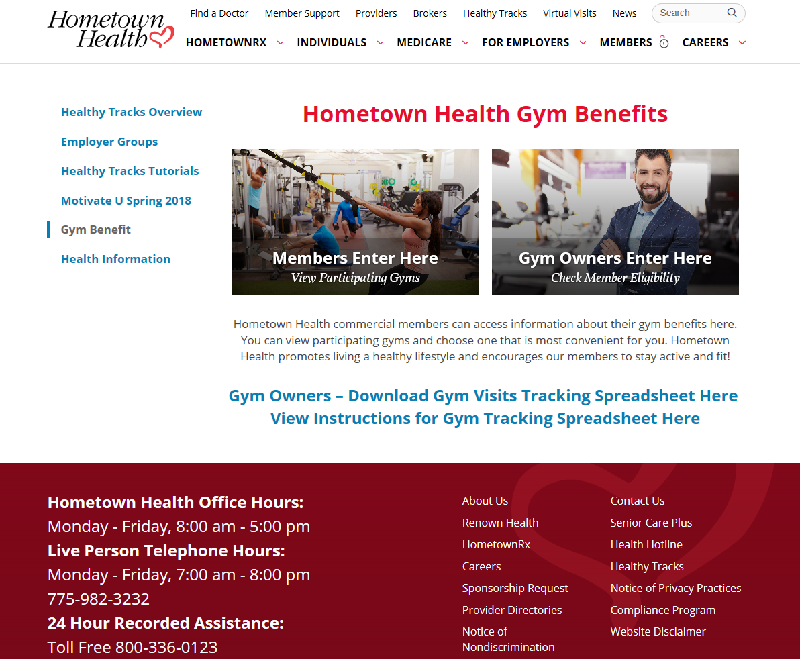

* Click on ***Check Gym Eligibility***to view member’s eligibility for program.

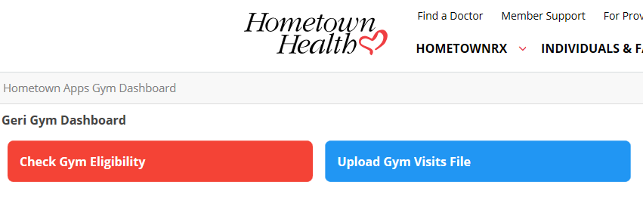

* Enter *Member Number* from member’s Hometown Health Identification Card (number should be 10 digits), and Click ***Submit.***

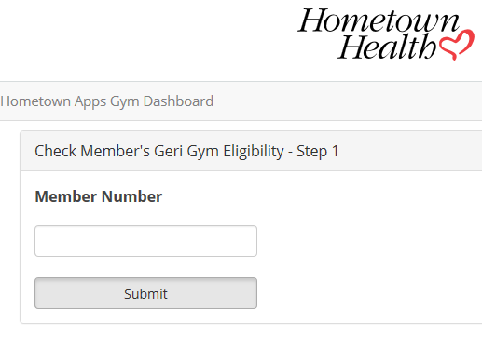

* Enter Member’s *Date of Birth* and Click ***Submit***.

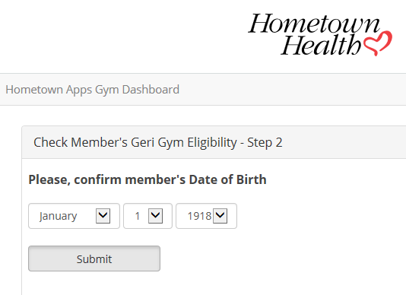

* Message will appear confirming that your client/member is eligible for the Hometown Fitness Gym Program.

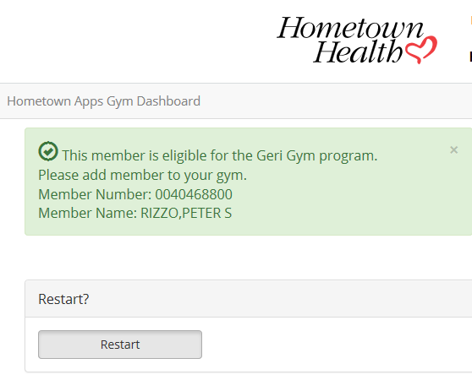

Member’s Number and Name will be displayed in this area

* Click on ***Restart*** to check another member’s eligibility

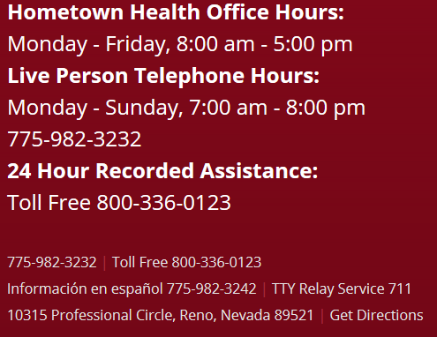

Hometown Fitness Gym Program Uploading Gym Visit Tracking Sheet

* Log on to [www.HometownHealth.com](http://www.HometownHealth.com) and click on the ***Healthy Tracks*** link.



* Click on the ***Gym Benefit*** link.



* Click on the ***Gym Owners Enter Here*** box.

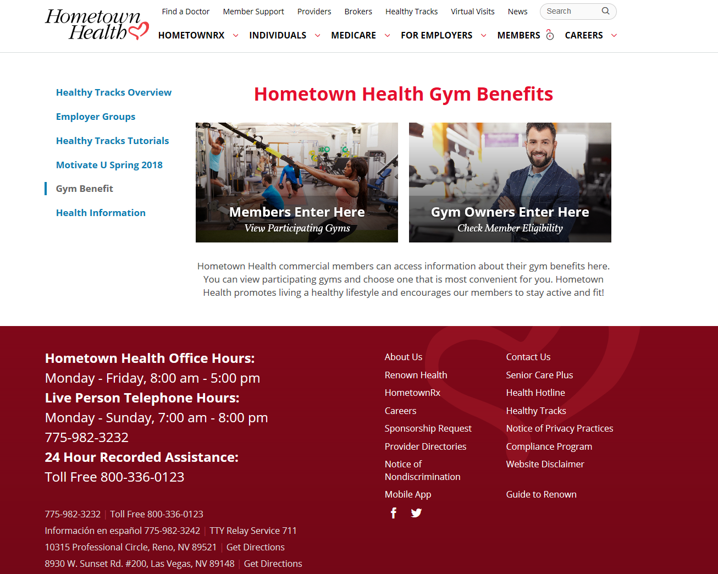

* If you have not already done so, download the ***Gym Visits Tracking Sheet*** by clicking on the link shown below

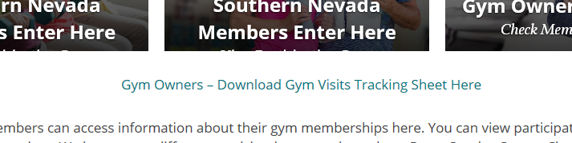

* Save to utilize to submit member visits to Hometown Health for membership payment. See separate instructions regarding uploading tracking sheet to Hometown Health via GlobalScape site.

Instructions for completing the Hometown Fitness Gym Program Billing Spreadsheet

1. Please use *only the supplied Electronic* Excel file *(Downloaded from the website as instructed above)* to bill Hometown Health for the monthly utilization for the Hometown Fitness Gym Program.
2. Please make sure that you complete a SEPARATE spreadsheet for each location you own and upload the spreadsheet to the correct account on our FTP site. *Please see uploading instructions for further information*. ALL locations have a separate login for the FTP site even if there is common ownership between locations! It is important to get the correct member billing listed under the correct entity or you will run into problems for the next billing!
3. Please list the Hometown Health or Senior Care Plus member identification number for each member you are submitting a bill for, as well as the date(s) of each visit to your location.
4. Use only the Hometown Health or Senior Care Plus member numbers from the member’s identification card. We will not be able to process the billing if the 10-digit number is not listed or incorrect. If you have any other questions or concerns please call (775) 982-3093 or email [bgrace-smith@hometownhealth.com](mailto:bgrace-smith@hometownhealth.com).

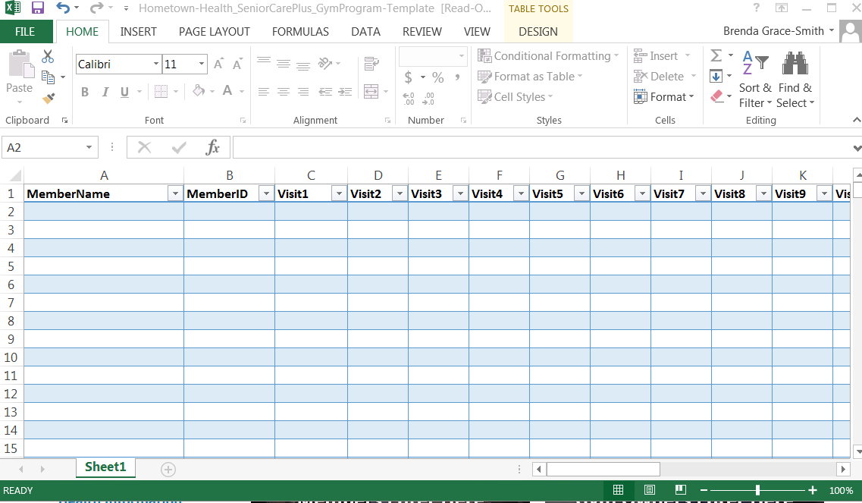

Best Practices and Troubleshooting

* Download Excel file *Gym Visit Tracking Document* from the Hometown Health website (see instructions included). This will open as an Excel file for your convenience.
* Spreadsheet has 33 columns, consisting of:
  + Member’s Name (Optional) (first column)
  + Member’s Identification Number (second column)
  + 31 Date-Ready columns to enter each member’s visit date throughout the logged month. Each date must be entered into a separate column. Duplicate dates will be ignored.
* Dates must be entered as MM/DD/YYYY. If this format is not followed, the download may be inaccurate and visits may be missed.
* Blank spaces, commas, or other characters can cause errors during the load process~~.~~
* DO NOT ADD OR REMOVE ROWS OR COLUMNS. This can cause the file to error out, which can delay your membership payment from Hometown Health.

Should you need further assistance, please feel free to reach out to me. I have also included our business information below.

|  |  |
| --- | --- |
| [http://www.skillexpertiseandtechnology.com/emailtemplate_images/Email_sign_HTH.png](http://www.hometownhealth.com/) | **Brenda Grace-Smith  |  Manager of Sales and Marketing  10315 Professional Circle, Reno, NV 89521  P 775-982-3093 | F 775-982-3090** |

