How to register for Healthy Tracks:

- To register for a Healthy Tracks account you will need the following:
  - Your Hometown Health Insurance Card
  - A valid email address

- Click on “Register”. As you fill out the registration form:
  - Enter your first and last name as they appear on your Hometown Health insurance card. No middle initial is required.
  - Enter a valid email address. After you submit the form, you will receive an email asking you to confirm you registration. This will also be your username when logging into Healthy Tracks.
  - Create a password that is a minimum of 8 characters in length and includes at least one uppercase letter, one lowercase letter and one number.

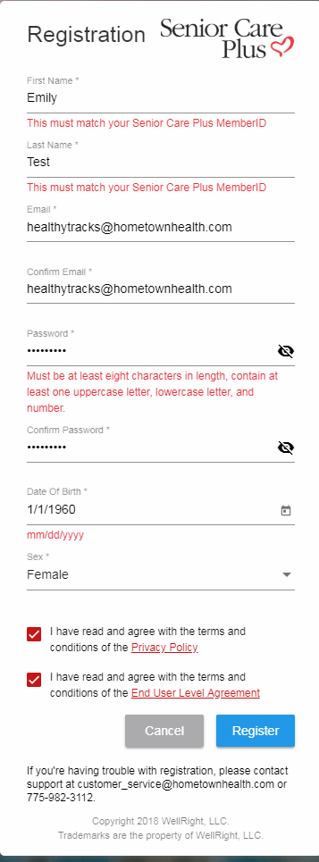
- After clicking “Register” the box below will appear on your screen.

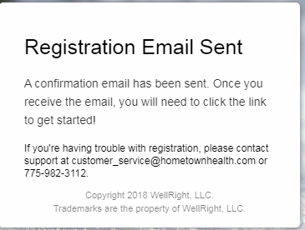
- Next, open up your email account. Open the email from Healthy Tracks. If you do not see an email from Healthy Tracks, look in the Junk or Spam folder.
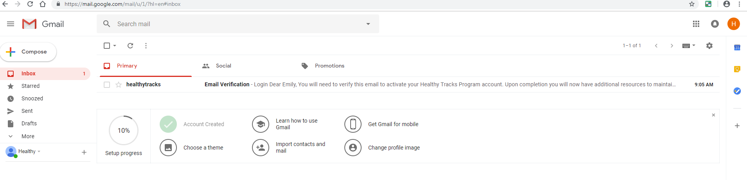

- In the Healthy Tracks email that you received, click on the “Email Verification” link. This is a secruity measure that verifies your email address with Healthy Tracks.
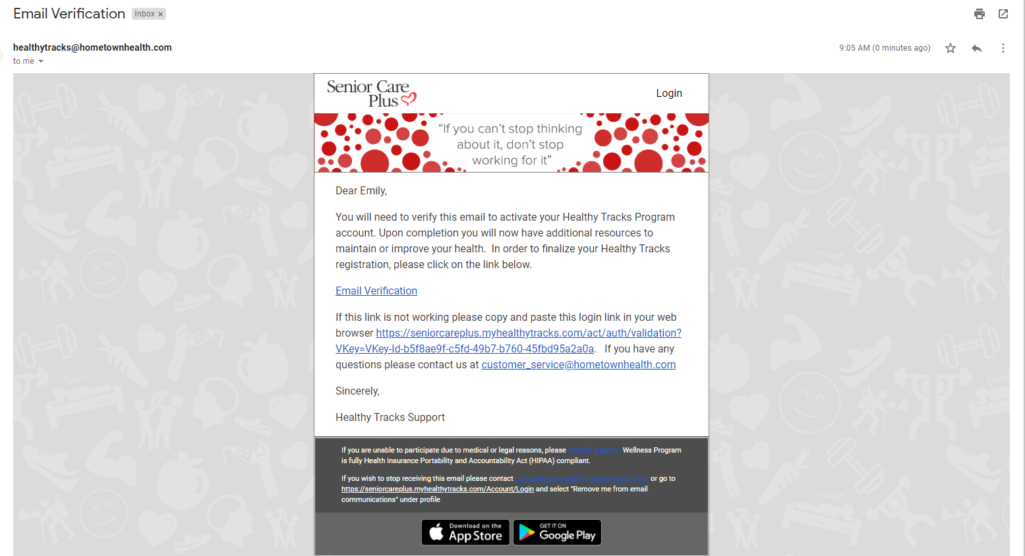

- You have now successfully verified your email! The Healthy Tracks website will open and ask you to enter your height, weight and mobile number. This is optional. If you prefer to skip this step, click on “Continue” in the bottom right corner.

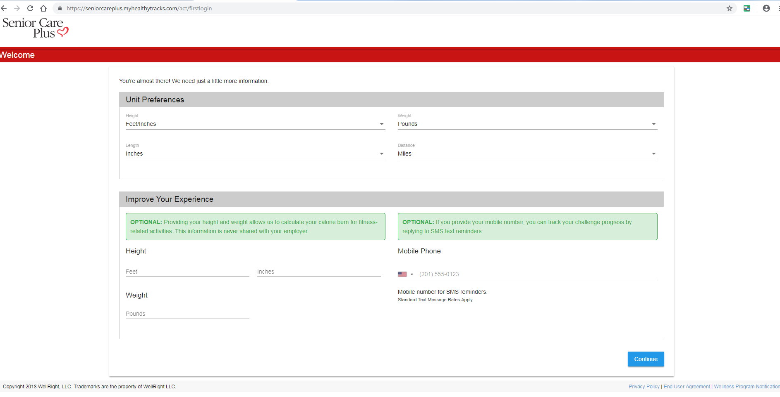

- After you select “Continue”, your Healthy Tracks homepage will appear. Congratulations! You have completed your Healthy Tracks registration! If you would like assistance registering your account, please call the Healthy Tracks Team at 775-982-6644.

